BAR CHART - DISTRIBUTION OF CUSTOMER AGES
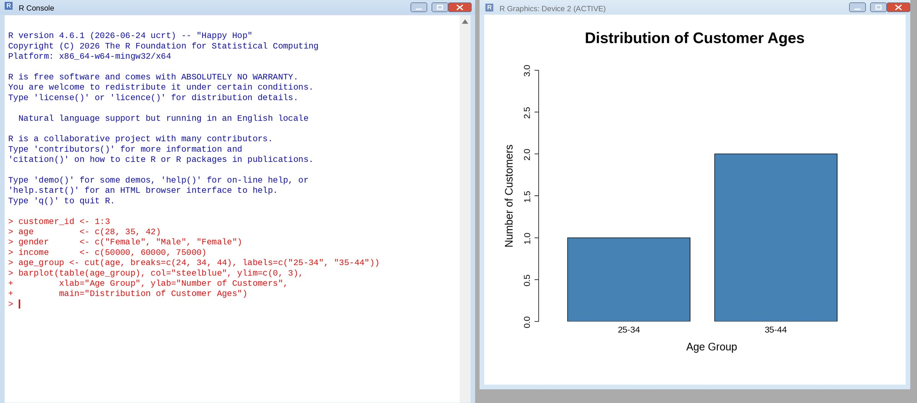
PIE CHART - CUSTOMERS BY GENDER
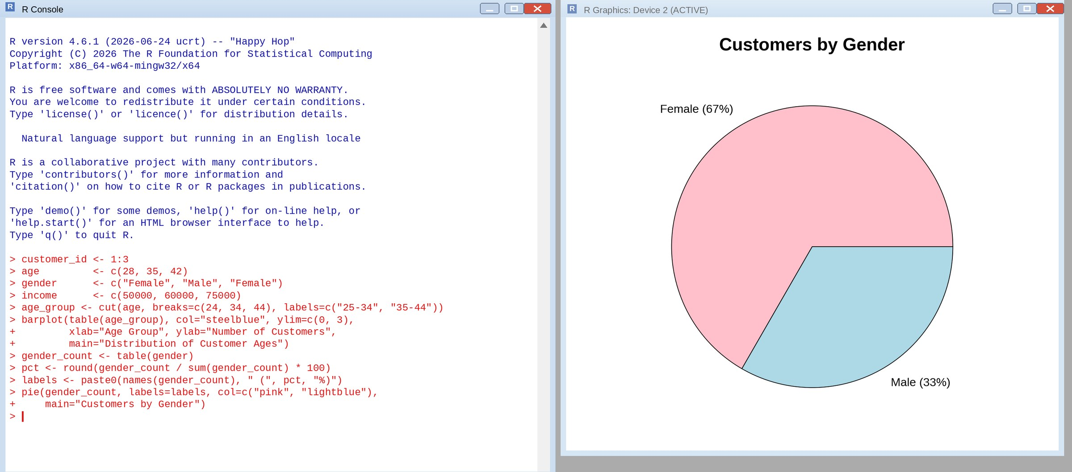
TABLE - CUSTOMER DEMOGRAPHICS
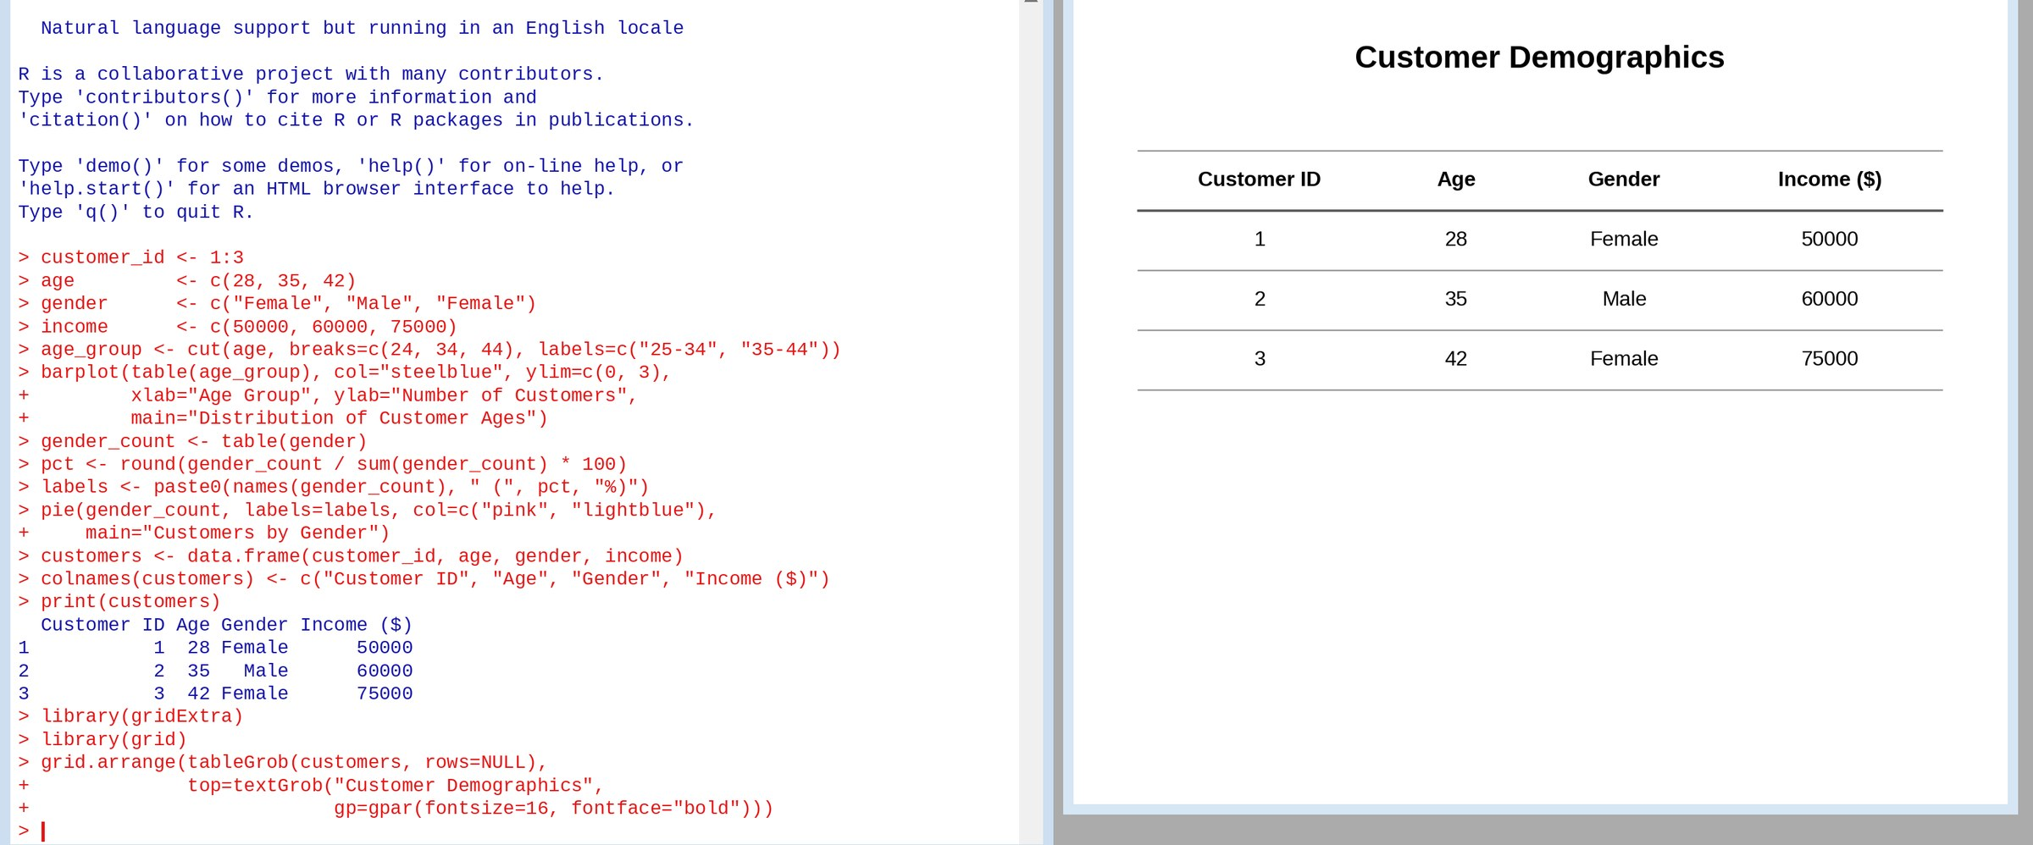
TABLEAU DASHBOARD - BAR CHART, PIE CHART AND TABLE
